Making a Project in Quartus Prime
Quartus Prime 18.1

The goal of this intro is to design a half-adder circuit in a new Quartus project.
Setting up the project:
- Click File > New Project Wizard.
- Skip over the introduction,
- Set the path of the project. Create a new folder in your documents. If you are using a lab computer, create a new folder somewhere in your OneDrive folder. Name the folder ‘halfadder’
- Name the project ‘halfadder’
- Click Next
  - 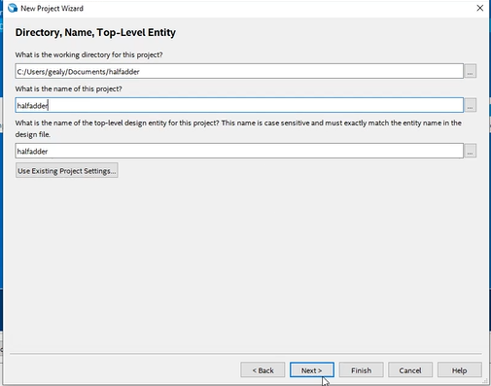
- Select Project Type > Empty Project. Click next.
- Do not add any files yet. Click next.
- Under the Device family, select MAX 10. Use the name filter to search for ‘10M50DAF484C7G’. Select the device in the available devices section. Click Next
  - 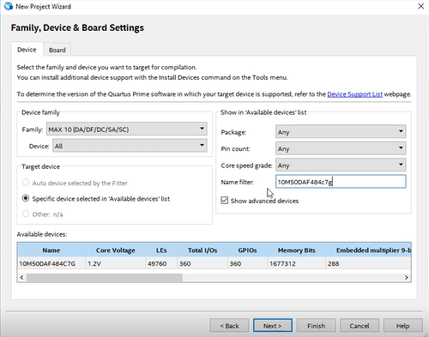
- Click Next then click Finish.
Start the design
- Click File > New
- Select VHDL file from the window. Click OK.
  - 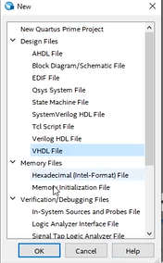
- Type the VHDL for the half adder circuit
  - 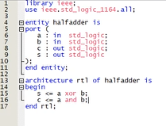
- Save the file as halfadder.vhdl. Since this VHDL file is the top entity of our project, the name of the file must EXACTLY match our project name and the name of the entity. If your top-level entity name does not match your project name, it will not compile.
- Double-click the Analysis & Synthesis button. The file should synthesize, and a green check should appear.

